PAPER EVALUATION USING ARTIFICIAL INTELLIGENCE (HYBRID AI FRAMEWORK FOR RESEARCH PAPER EVALUATION AND REVIEWER RECOMMENDATION)
Conclusion, Future Scope and References
Department of Computer Science and Engineering, TKR College of Engineering & Technology
Batch C8 (CSE-C) · Academic year [ACADEMIC YEAR]
Table 1: Project team
S.No. | Student name | Roll number
1 | Mula Sreebindu | 23K91A05G3
2 | Puramshetty Vishnu Vardhan | 23K91A05K2
3 | K Sampoorna | 24K95A0512
4 | Korsa Shivashankar | 24K95A0515

Project guide: M Anupama
Chapter and section numbers quoted in the text (for example Chapter 8 or Section 6.2) refer to the full project report, 17.Final Document. Figures and tables in this document are numbered from 1.

1. CONCLUSION

1.1 Summary
PeerScope is a working local application that turns a research-paper PDF into a preliminary assessment and an auditable ranking of candidate reviewers. A FastAPI service extracts the text with PyMuPDF, detects sections and references, computes structural signals, adds a historical decision signal from a TF-IDF and logistic-regression model, drafts a critique with a local Qwen2.5-1.5B model when it can be loaded, retrieves related work from OpenAlex and ranks reviewers with a score that combines sentence-embedding similarity, keyword and method overlap, availability and a conflict penalty. A React interface shows every result and its audit breakdown, and the analyses are stored and can be exported. The whole system runs on one CPU-only PC.

1.2 Objectives achieved
Of the six objectives, three were met (topics, methods and keywords were extracted; reviewer expertise was represented as comparable vectors; similarity-based ranking was computed and measured) and three were met in part. The table gives the status of each and the reason.
Table 2: Objectives against outcomes
No. | Objective | Status | Outcome
1 | Build a corpus of papers and reviewer publication profiles | Partly met | Analyses are stored; 6 demo reviewer profiles with CSV import; no real publication corpus; decision data synthetic
2 | Extract topics, methods and keywords with NLP | Met (simple) | Frequency keywords, a 21-term method lexicon and 18 topic hints
3 | Represent reviewer expertise as comparable vectors | Met | Profile text and titles embedded with all-MiniLM-L6-v2; no real publication history
4 | Compute semantic similarity to rank reviewers | Met | Top-1 95.0% with embeddings and 75.0% with the fall-back on 40 probe abstracts
5 | Preliminary assessment of structure, novelty signals and completeness | Met except novelty | Structure, evidence, method clarity, presentation, decision signal and critique; novelty reported as inconclusive
6 | Evaluate assignment quality against expert judgement and conflict handling | Partly met | Team-written labels, not independent experts; 12 of 12 literal conflict links found, 0 of 3 paraphrased

1.3 Key findings
1. Sentence-embedding similarity is the signal that matters for matching: on the probe set semantic-only ranking reached top-1 97.5%, the shipped hybrid 95.0% and keyword-and-method overlap alone 62.5%; the lexical terms mainly make the score explainable.
2. The offline TF-IDF fall-back is clearly weaker (top-1 75.0%), so the interface must, and does, say which embedder was used.
3. Auditing is cheap and useful: because every term is returned, a wrong recommendation can be traced; in both probe misses the reviewer ranked first was Reviewer Gamma (applied machine learning and statistics), and the breakdown shows the expected reviewer's lower semantic term.
4. The decision model shows the pipeline works but not that it predicts real decisions: accuracy 0.55, macro F1 0.509, ROC-AUC 0.77, accept against reject 93% correct, borderline recall 7%, with the accuracy ceiling near 0.56 fixed by the synthetic labelling.
5. The local language model dominates the cost: about 509 s of the 514 s that one analysis of the demo paper takes in-process; without it a paper is analysed in about a second.
6. Literal conflict detection is reliable (12 of 12, no false flags on 240 pairs) but blind to paraphrase (0 of 3).
7. Compared with the base paper [1], PeerScope adds paper assessment, availability and conflict handling and an application, and gives up its keyword-induction ensemble and its large, statistically tested evaluation; the results cannot be compared directly.

1.4 Practical applications
• A first-pass screening aid for an editor or programme chair, showing at once whether a paper has the sections, references and method detail a review needs.
• A short list of reviewers with reasons, matched terms, workload and conflict warnings, to be checked by the editor before any invitation.
• A teaching example of auditable decision support: how a transparent score, visible fall-backs and honest metrics can be combined.
• A base for a departmental or small-conference workflow where manuscripts must stay on local machines.

1.5 Known limitations
The decision model rests on synthetic data, the reviewer pool is a set of demo profiles, the matching evidence comes from abstracts written by the team, novelty is not assessed, conflict detection is literal, the local model is slow and unverified, and the application has no authentication and has had no user study. It is a research and teaching prototype for decision support, not a system to be used as the sole basis for publication decisions. The scope document lists the twelve limitations with their effects.
The results behind the key findings are shown below: the per-class behaviour of the decision model, and how reviewer-matching quality depends on the embedding that is available.
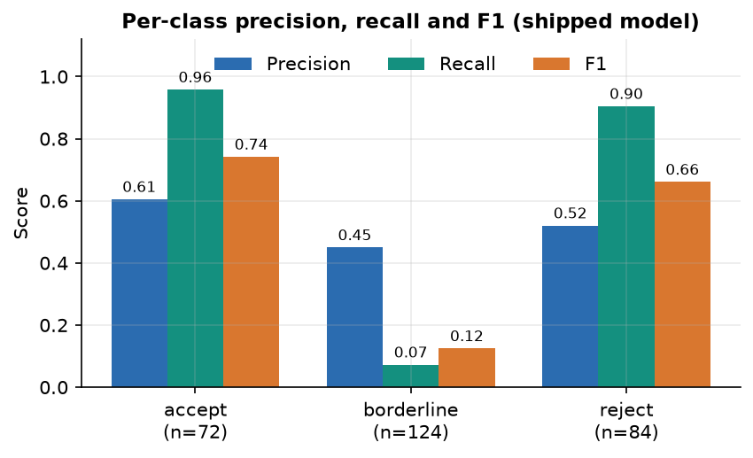
Figure 1: Precision, recall and F1 of each decision class on the held-out split: accept and reject are found, borderline is not.
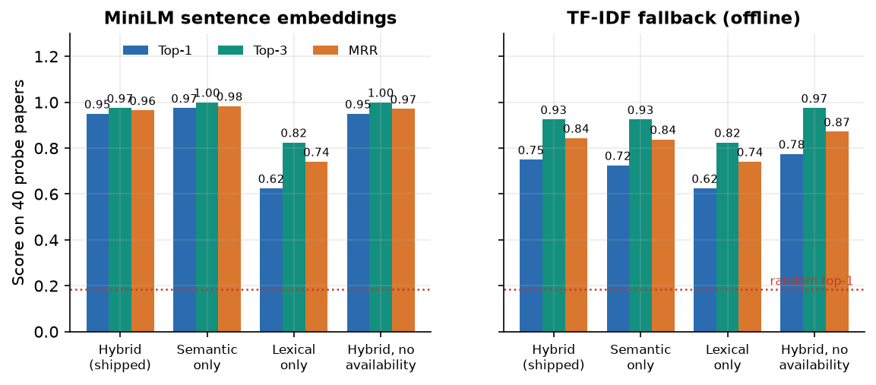
Figure 2: Reviewer-matching quality on 40 probe papers for four score configurations, with sentence embeddings and with the TF-IDF fallback.

2. FUTURE SCOPE

2.1 Improvements to the assessment
• Real decision data first. Replace the synthetic corpus with PeerRead [22] or decisions and reviews crawled from OpenReview, split by venue and year, and report accuracy and macro F1 against a majority baseline; this is the most important missing measurement.
• Independent labels for matching. Ask domain experts to judge the suitability of reviewers for real submissions, or reuse the historical assignments as the base paper does, and report MRR@3 and P@3 so that results become comparable.
• Novelty. Compare the paper's embedding with its retrieved neighbours and with a citation context, and replace the fixed Novelty value by a measured, caveated signal.
• Better parsing. Recognise roman-numeral and unnumbered headings, take the title from document metadata and the first page layout, and use a layout-aware parser for two-column papers.
• Fitted structural weights. Collect human ratings of structure and fit or at least sensitivity-test the 0.35, 0.25, 0.25 and 0.15 weights.

2.2 Additional features
• Publication-history ingestion. Build reviewer vectors from OpenAlex or Semantic Scholar records (titles, abstracts, venues) and add h-index and recency, as the batch abstract intended.
• Global assignment. Add an optimiser with load balancing and per-paper coverage constraints on top of the ranking, with bidding as an optional signal.
• Stronger conflict handling. Co-authorship and affiliation graphs, fuzzy matching of names and institutions, and a review of flagged pairs by the editor.
• Sanitised literature queries. Strip punctuation, retry with keywords when the title fails, and cache results; this also removes the HTTP 400 seen on titles with a question mark.
• Zone-aware times and stricter validation. Show times in the user's zone, reject files from which almost no text can be read, and report CSV rows that were skipped.

2.3 Scalability and deployment
• Embedding cache. Store profile embeddings and refresh them when a profile changes; ranking 500 reviewers currently takes about 5.2 s because every profile is re-embedded on each request.
• Faster local model. Run a quantised model or use a GPU, stream the tokens to the interface and let the user see the deterministic result while the critique is still being written.
• Authentication and roles. Accounts for editors and administrators, restricted origins, audit of who exported what, before any use beyond one machine.
• Packaging. A container for the whole application including the web interface, a database such as PostgreSQL for several users and a job queue for long analyses.
• Continuous evaluation. Run the measurement scripts, the seven tests and the smoke test in a CI pipeline.

2.4 Further research
• Study whether LLM keyword induction with a judge, as in the base paper [1], improves the keyword and method terms of this system, and measure its cost.
• Add a filter and an evaluation for prompt injection hidden in PDFs [2, 27], and measure how far the critique can be steered.
• Check the faithfulness of the language-model critique against the paper text and measure how often it states things the paper does not contain.
• Run a user study with editors and reviewers to measure time saved, trust in the explanations and the effect of the disclaimers.
• Investigate fairness and diversity effects of embedding-based ranking, such as reviewers from small institutions or new fields being ranked lower.

3. REFERENCES
[1] F. Bagheri, D. Buscaldi and D. Reforgiato Recupero, "LLM-assisted reviewer assignment via auditable expertise matching," IEEE Access, vol. 14, pp. 127834-127863, 2026, doi: 10.1109/ACCESS.2026.3724622.
[2] F. Torrielli, S. Locci, A. Rapp and L. Di Caro, "How to get your paper accepted by an AI reviewer: indirect prompt injection in peer review," Research Square preprint, Jan. 2026, doi: 10.21203/rs.3.rs-8432945/v1. (Published as "Exploiting large language models in peer review: indirect prompt injection attacks and integrity probes," Scientometrics, vol. 131, no. 7, pp. 4889-4951, 2026, doi: 10.1007/s11192-026-05695-x.)
[3] Y. Sermet and I. Demir, "Unveiling the reviewer mindset: evidence-based insights into scholarly peer review," ScienceOpen, May 2025, doi: 10.14293/ease.2025.037.
[4] Anonymous reviewer, "Review of: Performance evaluation of adaptive introgression classification methods. Round#1/Reviewer#2," Peer Community in Evolutionary Biology, Jun. 2024, doi: 10.24072/pci.evolbiol.100835.rev12.
[5] Anonymous reviewer, "Review of: Performance evaluation of adaptive introgression classification methods. Round#2/Reviewer#2," Peer Community in Evolutionary Biology, Dec. 2024, doi: 10.24072/pci.evolbiol.100835.rev22.
[6] S. Wu, O. Jiang, Y. Zhao, T. Hu, Y. Ma, K. Zhang, M. Patwardhan and A. Cohan, "Can AI be a good peer reviewer? A survey of peer review process, evaluation, and the future," arXiv:2604.27924, Apr. 2026.
[7] S. Li, L. Fan, Y. Lin, Z. Li, X. Wei, S. Ni, H. Alinejad-Rokny and M. Yang, "Automatic paper reviewing with heterogeneous graph reasoning over LLM-simulated reviewer-author debates," arXiv:2511.08317, Nov. 2025 (AAAI 2026 copyright notice on the PDF).
[8] J. Jovanovic and E. Bagheri, "Reviewer assignment problem: a scoping review," arXiv:2305.07887, May 2023.
[9] X. Zhao and Y. Zhang, "Reviewer assignment algorithms for peer review automation: a survey," Inf. Process. Manage., vol. 59, no. 5, Art. no. 103028, Sep. 2022, doi: 10.1016/j.ipm.2022.103028.
[10] L. Charlin, R. S. Zemel and C. Boutilier, "A framework for optimizing paper matching," arXiv:1202.3706, Feb. 2012.
[11] D. Mimno and A. McCallum, "Expertise modeling for matching papers with reviewers," in Proc. 13th ACM SIGKDD Int. Conf. Knowl. Discovery Data Mining, 2007, pp. 500-509, doi: 10.1145/1281192.1281247.
[12] I. Stelmakh, N. B. Shah and A. Singh, "PeerReview4All: fair and accurate reviewer assignment in peer review," arXiv:1806.06237, 2018 (Proc. Algorithmic Learn. Theory, 2019, pp. 828-856, as cited in [1]).
[13] A. Beygelzimer, Y. N. Dauphin, P. Liang and J. W. Vaughan, "Has the machine learning review process become more arbitrary as the field has grown? The NeurIPS 2021 consistency experiment," arXiv:2306.03262, Jun. 2023.
[14] K. Bouanane, A. N. Medakene, A. Benbelghit and S. B. Belhaouari, "FairColor: an efficient algorithm for the balanced and fair reviewer assignment problem," Inf. Process. Manage., vol. 61, no. 6, Art. no. 103865, Nov. 2024, doi: 10.1016/j.ipm.2024.103865.
[15] S. Jecmen, H. Zhang, R. Liu, N. B. Shah, V. Conitzer and F. Fang, "Mitigating manipulation in peer review via randomized reviewer assignments," arXiv:2006.16437, Jun. 2020.
[16] Y. Zhang, Y. Shen, S. Kang, X. Chen, B. Jin and J. Han, "Chain-of-factors paper-reviewer matching," in Proc. ACM Web Conf. 2025, Apr. 2025, pp. 1901-1910, doi: 10.1145/3696410.3714708.
[17] G. Salton and C. Buckley, "Term-weighting approaches in automatic text retrieval," Inf. Process. Manage., vol. 24, no. 5, pp. 513-523, 1988, doi: 10.1016/0306-4573(88)90021-0.
[18] K. Sparck Jones, "A statistical interpretation of term specificity and its application in retrieval," J. Documentation, vol. 28, no. 1, pp. 11-21, 1972, doi: 10.1108/eb026526.
[19] N. Reimers and I. Gurevych, "Sentence-BERT: sentence embeddings using Siamese BERT-networks," in Proc. EMNLP-IJCNLP, 2019, pp. 3980-3990, doi: 10.18653/v1/D19-1410.
[20] W. Wang, F. Wei, L. Dong, H. Bao, N. Yang and M. Zhou, "MiniLM: deep self-attention distillation for task-agnostic compression of pre-trained transformers," arXiv:2002.10957, Feb. 2020.
[21] A. Cohan, S. Feldman, I. Beltagy, D. Downey and D. S. Weld, "SPECTER: document-level representation learning using citation-informed transformers," in Proc. 58th Annu. Meeting Assoc. Comput. Linguistics, 2020, pp. 2270-2282, doi: 10.18653/v1/2020.acl-main.207.
[22] D. Kang, W. Ammar, B. Dalvi, M. van Zuylen, S. Kohlmeier, E. Hovy and R. Schwartz, "A dataset of peer reviews (PeerRead): collection, insights and NLP applications," in Proc. NAACL-HLT, 2018, pp. 1647-1661, doi: 10.18653/v1/N18-1149.
[23] W. Yuan, P. Liu and G. Neubig, "Can we automate scientific reviewing?," J. Artif. Intell. Res., vol. 75, pp. 171-212, 2022, doi: 10.1613/jair.1.12862.
[24] W. Liang et al., "Can large language models provide useful feedback on research papers? A large-scale empirical analysis," NEJM AI, vol. 1, no. 8, Jul. 2024, doi: 10.1056/AIoa2400196.
[25] M. Zhu, Y. Weng, L. Yang and Y. Zhang, "DeepReview: improving LLM-based paper review with human-like deep thinking process," in Proc. 63rd Annu. Meeting Assoc. Comput. Linguistics, 2025, pp. 29330-29355, doi: 10.18653/v1/2025.acl-long.1420.
[26] Z. Zhuang, J. Chen, H. Xu, Y. Jiang and J. Lin, "Large language models for automated scholarly paper review: a survey," Inf. Fusion, vol. 124, Art. no. 103332, Dec. 2025, doi: 10.1016/j.inffus.2025.103332.
[27] J. Keuper, "Prompt injection attacks on LLM generated reviews of scientific publications," arXiv:2509.10248, Sep. 2025.
[28] A. Vaswani et al., "Attention is all you need," in Proc. Adv. Neural Inf. Process. Syst., vol. 30, 2017 (arXiv:1706.03762).
[29] A. Yang et al. (Qwen Team), "Qwen2.5 technical report," arXiv:2412.15115, Dec. 2024.
[30] T. Wolf et al., "Transformers: state-of-the-art natural language processing," in Proc. EMNLP: System Demonstrations, 2020, pp. 38-45, doi: 10.18653/v1/2020.emnlp-demos.6.
[31] F. Pedregosa et al., "Scikit-learn: machine learning in Python," J. Mach. Learn. Res., 2011 (arXiv:1201.0490).
[32] J. Priem, H. Piwowar and R. Orr, "OpenAlex: a fully-open index of scholarly works, authors, venues, institutions, and concepts," arXiv:2205.01833, 2022.

